Vector:

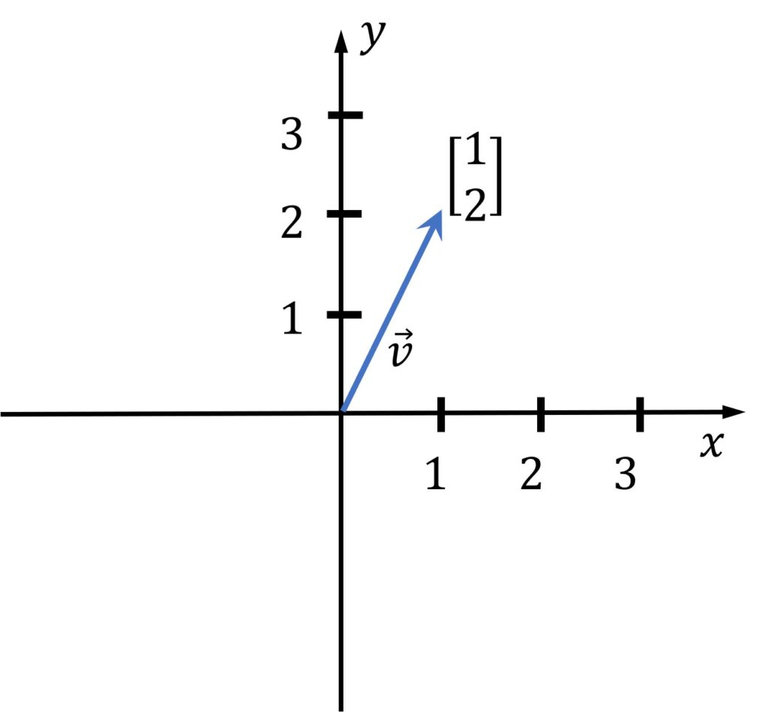

**Length of the Vector:**

Using Pythagoras theorem

$$Length of the Vecor(||V||)= \sqrt{a^{2}+b^{2}}$$

$$Length of the Vecor(||V||)= \sqrt{1^{2}+2^{2}}$$

$$Length of the Vecor(||V||)= \sqrt{1+4}$$

$$Length of the Vecor(||V||)= \sqrt{5}$$

**Unit Vector:**

A unit vector is one whose magnitude is equal to one. The "cap" symbol(^) indicates unit vectors. Unit vectors have a length of one. It is commonly used to describe a vector's direction.

Unit vector can be calculated by using the below formula

$$\frac{V}{(||V||)}=\left[\frac{a}{\sqrt{a}},\frac{b}{\sqrt{b}} \right]$$

$$\frac{V}{(||V||)}=\left[\frac{1}{\sqrt{5}},\frac{1}{\sqrt{5}} \right]$$

**Perpendicular vector:**

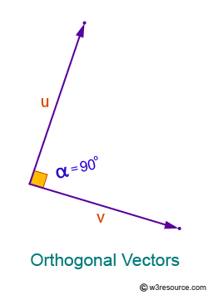

Two vectors are said to be perpendicular if the dot product of the same is 0.

Let us calculate the dot product of the above vectors.

$$\vec{u} =\left[2,5\right]$$

$$\vec{v} =\left[5,-2\right]$$

$u.v =u^{T}v=\left[\begin{matrix}2 \\ 5\end{matrix}\right]\left[5,-2\right]$

$$\left(2*5\right)+\left(5*-2\right)=0$$

$$\left(10\right)+\left(-10\right)=0$$

Hence it is proved that the above two vectors are perpendicular.

How do we prove the same for the plane?

The same is explained as below.

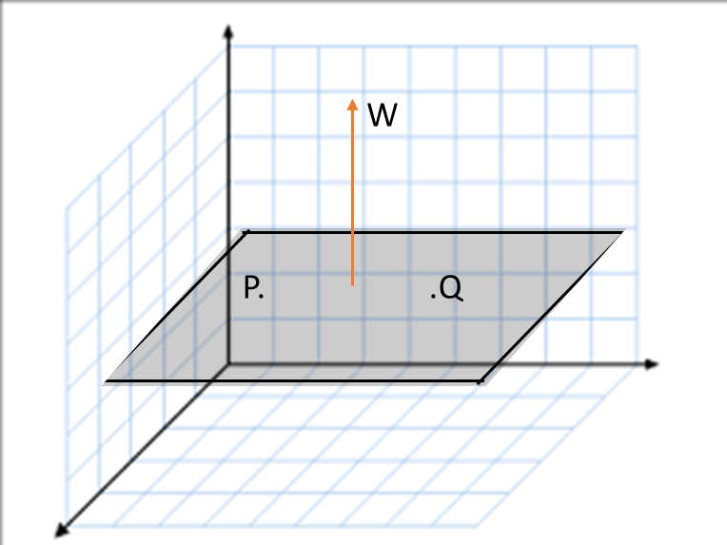

$$w_{1}x_{1}+w_{2}x_{2}++w_{3}x_{3} W_{0}=O$$

$$w^{T} x+ w_{0}=O$$

Suppose there are P and Q are the points on the plane

Proof

$$w_{1}P+w_{2}P+w_{3}P+ W_{0}=0$$

$$w^{T} P+ w_{0}=0$$

$$W^{T}P = -W_{0}$$

$$w_{1}Q+w_{2}Q+w_{3}Q+ W_{0}=0$$

$$W^{T} Q+ W_{0 }=0$$

$$W^{T} Q=- W_{0 }$$

$$W\left(P-Q\right)=0$$

$$W^{T} \left(Q-P\right)=0$$

$$W^{T}P- W^{T}Q=0$$

$$\left(-W_{0}\right)-(- W_{0 })=0$$

Hence it is proven that w is perpendicular to the plane

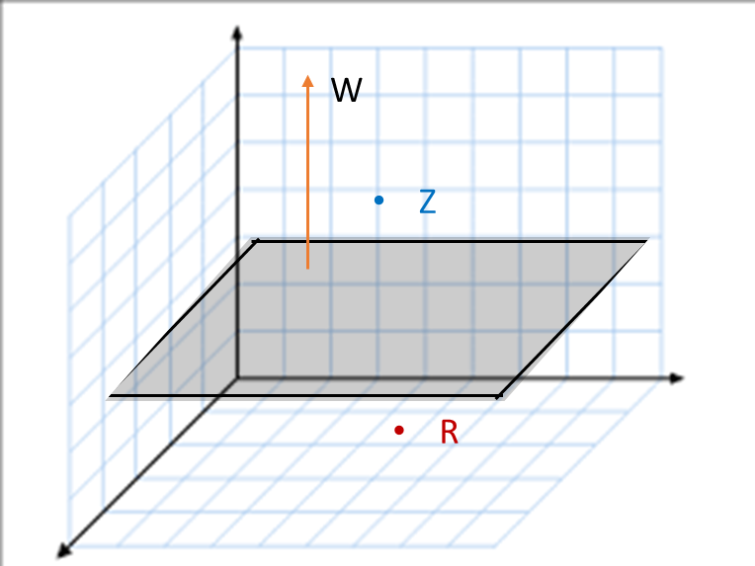

Consider w is a vector which is perpendicular to the plane and $Z and P$ are the point situated above and below of the plane respectively.

IF point lies on the side of the vector it means it is +ve points.

$$d =\frac{w_{1}z_{1}+w_{2}z_{2}+w_{3}z_{3}+ W_{0}}{|\left|w\right||}$$

$$d= \frac{W^{T}Z+ W_{0} }{|\left|w\right||}$$

$\frac{W^{T}Z+ W_{0} }{|\left|w\right||}=+ d$

$$\left|\left|w\right|\right| \left|\left|z\right|\right| cosθ=+d$$

IF the point lies on the opposite side of the vector it means it is -ve points.

$$d=\frac{w_{1}R_{1}+w_{2}R_{2}+w_{3}R_{3}+ W_{0}}{|\left|w\right||}$$

$$d = \frac{w^{T}R+ w_{0} }{|\left|w\right||}$$

$$\frac{w^{T}R+ w_{0} }{|\left|w\right||}=-d$$

$$\left|\left|w\right|\right| \left|\left|R\right|\right| cosθ=-d$$

Based on the abode if the point is above the plane has +ve distance and points placed below the plane or opposite side of the vector will have –ve distance.

Using the above equation, we can determine the position of the points (values) relative to the hyperplane, weather it lies above or below the hyperplane.

The crucial factor in this equation is the role played by cosine theta (cosθ), as it helps ascertain the point's position based on the angle it forms with the vector.   
- points with an angle **less** than 90 degrees yield a **positive value**,   
- while those with an angle **greater** than 90 degrees result in a **negative value**.

Consequently, we can conclude that all positive values lie above the plane, whereas all negative values lie below the hyperplane.

**Monotonic Function:**

The log is a monotonic Function. Here if the x value increases the log of x also increases.

Example:

$$x=5 \log\left(x\right)=1.609$$

$$x=6 \log\left(x\right)=1.791$$

Considering the above we will use the same in armax

$\begin{matrix}argmax \\ k\end{matrix} kx$

At what k value kx is maximum

If k =1 kx =5

If k=2 kx = 6

However directly using argamx function we employ monotonic function log()

$$\begin{matrix}argmax \\ k\end{matrix} log⁡(kx)$$

If k =1 log(kx)=1.609

If k=2 log(kx) = 1.791

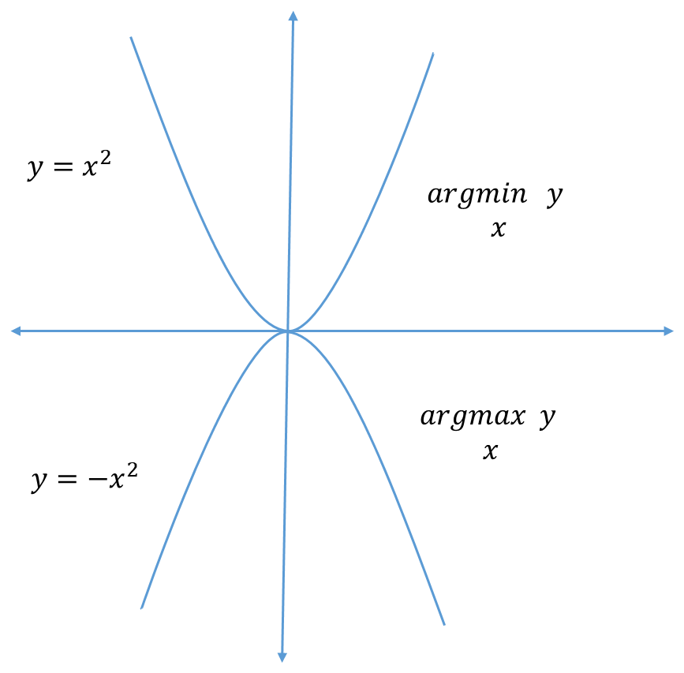

When considering the argument of the minimum (argmin), we determine the x value at which the corresponding y value will be minimized. Conversely, when examining the argument of the maximum (argmax), we seek the x value where the y value will be maximized. Interestingly, The maximum value of (argmax) and the minimum value of (argmin) is same.